# Indian Institute of Technology, Guwahati



Department of Computer Science and Engineering Project Report

On

# “Speech Based Browser Automation”

Based on

### Speech Recognition System

**Course: CS566 Speech Processing**

**GROUP NO 19**

Submitted to Prof. P.K..Das

Submitted by:

Keshav Parihar (214101025)

Mohit Kumar (214101029)

**TABLE OF CONTENT**

1. **Abstract**
2. **Introduction**
3. **Proposed Methodology**
4. **Experimental Setup**
5. **Result**
6. **Source code**

## ABSTRACT

#### This document defines a set of evaluation criteria and test methods for speech recognition systems used in searching and retrieving contact details. This report is on the project which detects the contact name and show its details

.

**INTRODUCTION**

In this report, we concentrate on the speech recognition programs that are human-computer interactive. When software evaluators observe humans testing such software programs, they gain valuable insights into technological problems and barriers that they may never witness otherwise. . Testing speech recognition products for universal usability is an important step before considering the product to be a viable solution for its customers later. This document concerns Speech Recognition accuracy in contact searching and retrieving details, which is a critical factor in the development of hands-free human- machine interactive devices. There are two separate issues that we want to test: word recognition accuracy and software friendliness. Major factors that impede recognition accuracy in the environment noise sources and system noise.

**However, what is speech recognition?**

Speech recognition works like this. You speak into a microphone and the computer transforms the sound of your words into text to be used by your word processor or other applications available on your computer. The computer may repeat what you just said or it may give you a prompt for what you are expected to say next. This is the central promise of interactive speech recognition. You also had to correct any errors virtually as soon as they happened, which means that you had to concentrate so hard on the software that you often forgot what you were trying to say.

The new voice recognition systems are certainly much easier to use. You can speak at a normal pace without leaving distinct pauses between words. However, you cannot really use “*natural speech*” as claimed by the manufacturers. You must speak clearly, as you do when you speak to a Dictaphone or when you leave someone a telephone message. Remember, the computer is relying solely on your spoken words. It cannot interpret your tone or inflection, and it cannot interpret your gestures and facial expressions, which are part of everyday human communication. Some of the systems also look at whole phrases, not just the individual words you speak. They try to get information from the context of your speech, to help work out the correct interpretation.

The goal of this project is to define a set of evaluation criteria and test methods for the interactive voice recognition systems for searching contact and retrieving corresponding details for successful search.

## PROPOSED METHODOLOGY

Basic requirements to develop this project are as follows:

* Windows OS
* Microsoft Visual Studio 2010
* C++ 11 integrated with VS2010
* Recording Module

#### With the availability of above software, we further proceed in modelling the logic. The prerequisites of this project are

* Basic i/o operations on file
* Pre-processing of speech data
* Feature extraction
* Modelling of extracted feature
* Enhancing model

With the availability of above tools, we further proceeded. Below is the flow chart for our project

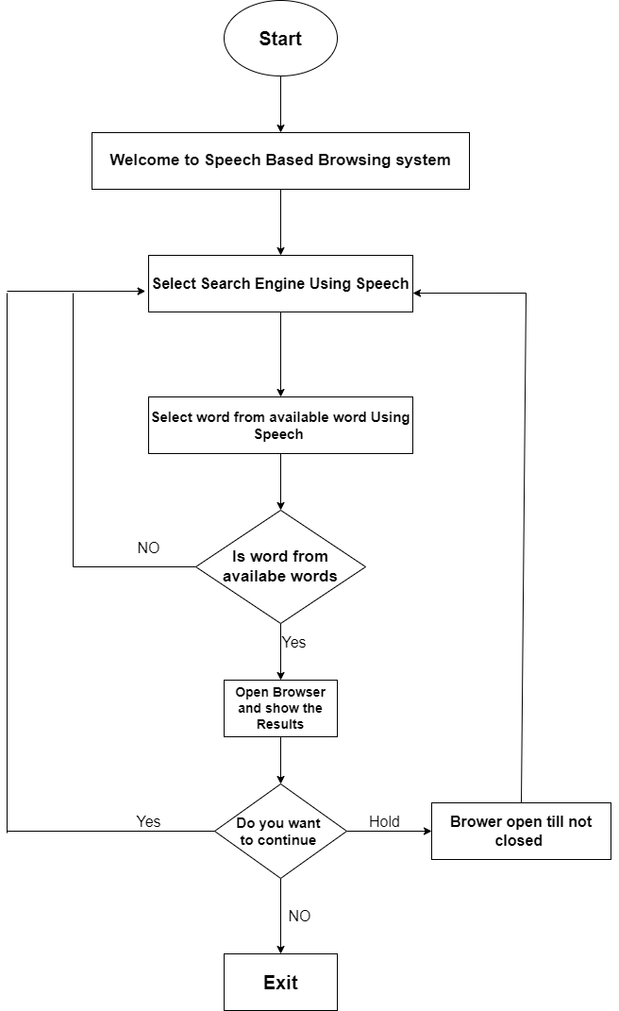

## EXPERIMENTAL SETUP

This project is divided into following modules:

1. **Training Module**
2. **Testing Module**
3. **Training Module**

The flow for training over data is as follows:

* 1. Record the data as 30 utterance of each word
  2. Extract frames for every utterance
  3. Using local distance analysis (in vector quantization) calculate the observation sequence.
  4. Pass this observation sequence to HMM for model designing.
  5. Now enhance the model using HMM re-estimation algorithm.

Now reference model is ready for our project. The training of data is not integrated with GUI application. This is different module, which will just evaluate reference model.

1. **Testing Module**

System will give instruction what is going on and user is required to follow it. The flow of testing is as follows:

* 1. Live recording of data is done when system instruct.
  2. Testing the data with retrained models.
  3. Detect the Search Engine
  4. Detect the word which has to be search
  5. If word is correctly spoken then it opens browser.
  6. If wrong word detected then ,record the input again.

1. **WORDS USED**
2. **START**
3. **STOP**
4. **YES**
5. **SEARCH**
6. **WIKIPEDIA**
7. **YOUTUBE**
8. **SPEECH**
9. **GOLD**
10. **CORONA**
11. **DOLLAR**
12. **SCREEN SHORTS**

**INITIAL WINDOW**

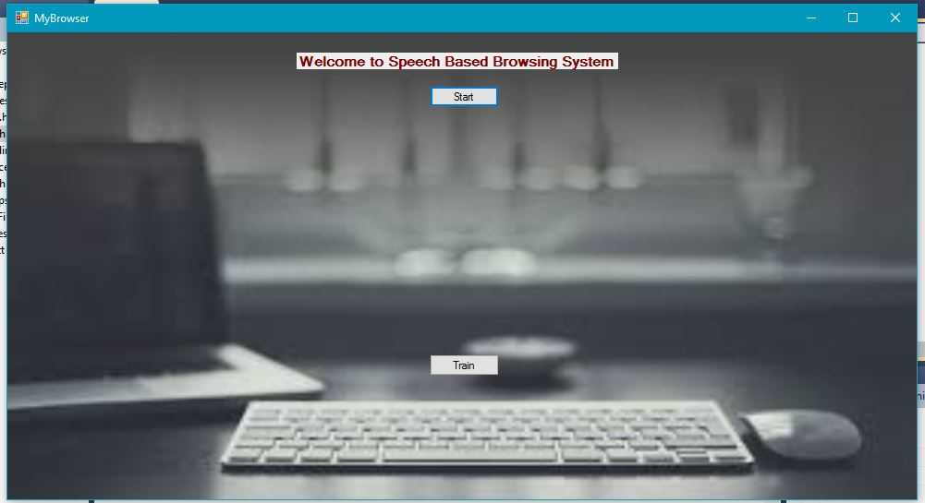

**WINDOW AFTER START**

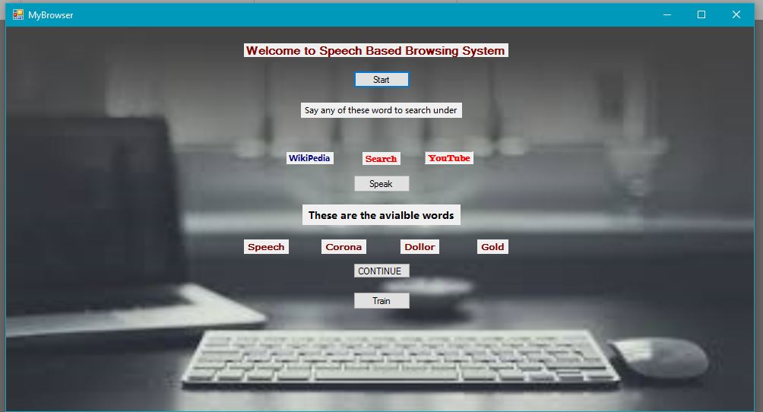

**CLICK TARIN BUTTON**

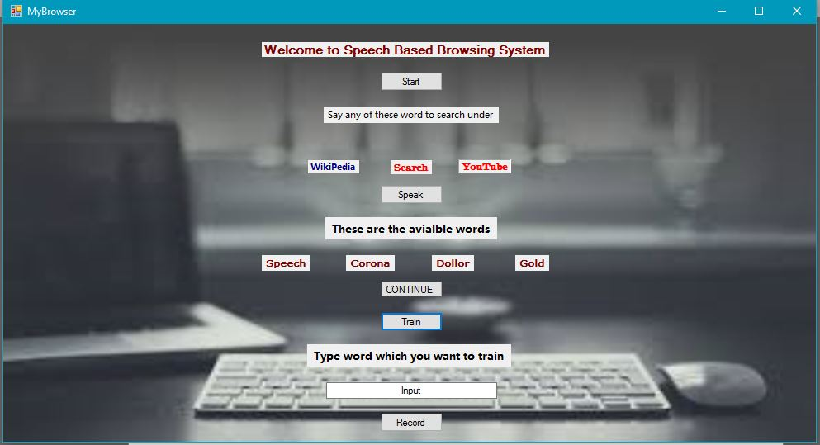

## 

## RESULT

For offline testing, we took 30 recordings of each word, with deterministic difference of maximum and second maximum P (O/lambda) we got 85% accuracy and without considering deterministic difference we got 95% accuracy.

The Spoken word will open in browser with selected Search engine i.e. YouTube , Google or Wikipedia , Then we search for the available words.

**SOURCE CODE**

#include "stdafx.h"

#include<iostream>

#include<iomanip>

#include<fstream>

#include<vector>

#include<string>

#include<ctype.h>

#include<string.h>

#include<cstring>

using namespace std;

typedef long double ld;

/////////////////////////////// VARIABLES USED FOR HMM //////////////////////////////////////////////////////////////////

#define N 5 // number of states

#define M 32 // number of distinct observation symbols

#define T 40 // number of frames

#define p 12 // number of capstral coefficients per frame

#define F 320 // size of a frame (320 samples)

vector<vector<long double>> cb; // codebook 32x12

vector<ld> data;

vector<ld> ob; // observation sequence

vector<ld> pi(N,0); // initial state distribution

vector<vector<ld>> a( N,vector<ld> (N,0)); // state transition probability distribution

vector<vector<ld>> b( N,vector<ld> (M,0) ); // observation symbol probability in state Sj

vector<ld> pi_sum(N,0);

vector<vector<ld>> a_sum(N,vector<ld> (N,0));

vector<vector<ld>> b_sum(N,vector<ld> (M,0) );

vector<ld> pi_bar(N,0);

vector<vector<ld>> a_bar(N,vector<ld> (N,0));

vector<vector<ld>> b_bar(N,vector<ld> (M,0) );

vector<vector<ld>> alpha(T,vector<ld> (N,0)); // FORWARD VAIABLE - probab. of partial onbserv. seq. o1,o2...ot

vector<vector<ld>> beta(T,vector<ld> (N,0)); // BACKWARD VARIABLE - joint probab. of ot+1,ot+2....oT at t ans state Si and model λ

vector<vector<ld>> delta(T,vector<ld> (N,0)); // best score (heighest prob.) along a single path at time t

vector<vector<ld>> psi(T,vector<ld> (N,0));

vector<vector<ld>> gama(T,vector<ld> (N,0));

vector<vector<vector<ld>>> zeta(T,vector<vector<ld>> (N,vector<ld> (N,0))); // ξ

vector<ld> qstar(T);

ld P,

pstar;

///////////////////////////////////////////////////////////////////////////////////////////////////////////////////////

/////////////////////////////// VARIABLES USED FOR CODEBOOK CALCULATION ///////////////////////////////////////////////

string read_line ;//TO READ LINES FROM FILES

ld

sampleval_x1=0, // FOR VALUES OF FILE

headerline_count=0, // READING HEADER FILE FOR NUMBER OF SAMPLE

normalised_value=0, //NORMALISED VALUES

// b=0,

no_of_frames=0, // NO OF FRAMES

l=0,

i=1,

min=0, //MINIMUM OF WHOLE DATA

max_of_data=0, //MAXIMUM OF WHOLE DATA

steadyframes_xi[100][320]={{0}} , //STEADY FRAME MATRIX CONTAINS VALUES OF 5 STEADY FRAMES

feature_ref_matrix[41][13]={{0}}, // FEATURE REFERENCE MATRIX CONTAINS VALUES OF RAISED SINE Ci VALUES

E=0 , //USED IN DURBIB ALGORITHM

k[13]={0,0,0,0,0,0,0,0,0,0,0,0} , //USED IN DURBIB ALGORITHM

sum=0, //USED IN DURBIB ALGORITHM

alpha_durbin[13][13]={{0}}, //USED IN DURBIB ALGORITHM

ri[13]={0,0,0,0,0,0,0,0,0,0,0,0,0} ,//

ai[13]={0,0,0,0,0,0,0,0,0,0,0,0} ,//

ci[13]={0,0,0,0,0,0,0,0,0,0,0,0} ,//

raisedci[13]={0,0,0,0,0,0,0,0,0,0,0,0} , //RAISED SINE Ci VALUES

resultant_feat_ref_maxtrix[6][13]={{0}}, //RESULTANT FEATURE REFERENCE MATRIX CONTAINS VALUES OF RAISED SINE Ci VALUES

tohkurad=0.0, //TOKHURA DISTANCE

tokhura_w[12]={1.0 ,3.0, 7.0, 13.0 ,19.0, 22.0 , 25.0,33.0,42.0,50.0,56.0,61.0}, //GIVEN TOKURA WEIGHTS

dc_shift=0.0; //DC SHIFT VALUE

int line_count=0 , // USE IN COUNTING THE INDEX VALUES

maxindex=0; //INDEX OF MAXIMUM VALUE IN NORMALISED VALUES FOR SEARCHING THE 5 5 STEADY FRAMES

///////////////////////////////////////////////////////////////////////////////////////////////////////////////////////

void dcshift(string &filename)

{

fstream f;

f.open(filename ,ios::in);

if(!f)cout<<"ERROR FOR DC SHIFT ::"<<filename<<"\n";

else

{

// cout<<"DC SHIFT ::"<<filename<<"\n";

while(line_count<=5*F) // TAKING FIRST 5 FRAMES

{

//cout<<i<<"\n";i++;

f>>read_line;

sampleval_x1=stold(read_line);

dc_shift=dc_shift+sampleval_x1;

//cout<<i-10<<" )"<<dc_shift<<"\n";

line_count++;

}

}

dc_shift=dc_shift/1600.0;

// cout<<"DC_SHIFT= "<<dc_shift<<"\n";

line_count=0;

f.close();

}

void findmax(string &filename)

{

max_of_data=0;

line_count=0;

maxindex=0;

fstream f;

f.open(filename ,ios::in);

if(!f)cout<<"ERROR FOR FIND MAX ::"<<filename<<"\n";

else

{

// cout<<"FIND MAX ::"<<filename<<"\n";

while(!f.eof())

{

f>>read_line;

line_count++;

sampleval_x1=stold(read_line);

if((max_of_data >= sampleval_x1))

{

max_of_data=max_of_data;

}

else

{

max_of_data=sampleval_x1;

maxindex=line_count;

}

}

line_count=0;

// cout<<"\nMAX= "<<" "<<max_of_data; // PRINTING MAX IN GIVEN FILE

// cout<<"\nMAX INDEX = "<<" "<<maxindex;

}

f.close();

}

////////////////////////////////FINDING STEADY FRAMEs /////////////////////////////////////////////////////////////

void findsteadyframes(string &filename)

{

fstream f;

f.open(filename,ios::in);

if(!f)cout<<"\nERROR FOR FIND STEADY FRAMES ::"<<filename<<"\n";

else

{

// cout<<"\nFIND STEADY FRAMES ::"<<filename<<"\n";

while(!f.eof())

{

f>>read_line;

sampleval_x1=stold(read_line);

line_count++;

if(line_count == (maxindex- 20*F))// TAKING 30 FRAMES LEFT OF MAX VALUE AND 70 FRAMES RIGHT OF MAX VALUE

{

for (int b = 0; b < 40 ; b++)

{

for(int d=0 ; d < 320 ; d++)

{

f>>read_line;

sampleval_x1=stold(read_line);

// cout<<sampleval_x1<<"\n";

steadyframes_xi[b][d]=sampleval_x1;// START SAVING STEADY FRAMES VALUES IN A MATRIX OF 5 x 12

// cout<<steadyframes_xi[b][d]<<" ";

}

// cout<<"---------------------------------\n";

}

break;

}

// if(sampleval_x1 >= (50/100)*max_of_data || sampleval_x1 <= -(50/100)*max_of_data )

// {

// f1<<read_line<<"\n";

// }

}//while ends......

}

f.close();

//NORMALISE/////////////////////////////////////////////////

for (int b = 0; b < 40 ; b++)

{

for(int d=0 ; d < 320 ; d++)

{

steadyframes_xi[b][d]= ((steadyframes_xi[b][d] - dc_shift ))*(5000/ (max_of_data));

}

}

////////////////////////////////////////////////////////////

///////////////////////////////////////////////////////////// checking the cut.......

fstream f1;

f1.open("log.txt",ios::out);

if(!f1)cout<<"\nerror...log"<<"\n";

else

{

f1.clear();

// cout<<"\nsucees...log";

for (int b = 0; b < 40 ; b++)

{

for(int d=0 ; d < 320 ; d++)

{

f1<<steadyframes_xi[b][d]<<"\n";

// sampleval_x1=stold(read_line);

// cout<<sampleval_x1<<"\n";

// steadyframes_xi[b][d]=sampleval_x1;// START SAVING STEADY FRAMES VALUES IN A MATRIX OF 5 x 12

// cout<<steadyframes_xi[b][d]<<" ";

}

// cout<<"---------------------------------\n";

}

}

////////////////////////////////////////////////////////////

}

void ci_cal()

{

for (int b = 0; b < 40 ; b++)

{

// cout<<"\nFRAME -->"<<b+1;

/////////////////////////////////// calculating ri ////////////////////////////////////////////////////////

// cout<<"\nCALCULATING R(i).....\n";

ld sum=0;

for (int i = 0; i <= 12; i++)

{

// if(i==1)break;

sum=0;

for (int j = 0; j <= 320 -1 -i ; j++)

{

sum = sum + steadyframes_xi[b][j] * steadyframes_xi[b][i+j];

// cout<<j+1<<" "<<test[j]*test[i+j]<<"\n";

// cout<<i<<" "<<i+j<<"\n";

} //cout<<"------------------------------------------\n\n";

feature_ref_matrix[b][i] = sum;

// cout<<a<<"\n";

}

// for (int i = 0; i <= 12; i++)

// {

// cout<<b<<" "<<i<<" "<<fixed<<setprecision(4)<<feature_ref_matrix[b][i]<<"\n";

// cout<<b<<" "<<i<<" "<<feature_ref_matrix[b][i]<<"\n";

// }

// cout<<"\n";

///////////////////////////////////////////////////////////////////////////////////////////////////////////

// //////////////////// ai ////////////////////////////////////////////////////////////////////////////////////

// cout<<"\nCALCULATING A(i).....\n";

E=feature_ref_matrix[b][0];

// cout<<fixed<<setprecision(8);

// cout<<E;

sum=0;

for (int i = 1; i <= 12 ; i++)

{

sum = 0.0;

// cout<<"\n\ni="<<i;

// cout<<"\nki -------------\n";

for (int j = 1; j <= i - 1; j++)

{

sum = sum + alpha_durbin[i - 1][j] * feature_ref_matrix[b][i - j ];

// cout<<"sum= "<<sum<<"\n";

}

// k[i] calculation

k[i] = (feature_ref_matrix[b][i] - sum) / E;

// cout<<"ki ="<<k[i]<<"\n";

// cout<<"alpha i i-------------\n";

alpha_durbin[i][i] = k[i];

// cout<<alpha[i][i]<<"\n";

// cout<<"alpha i j-------------\n";

//alpha calculation

for (int j = 1; j <= i - 1; j++)

{

alpha_durbin[i][j] = alpha_durbin[i - 1][j] - ( k[i] * alpha_durbin[i - 1][i - j] );

// cout<<alpha_durbin[i][j]<<"\n";

}

// cout<<"E -------------\n";

//Energy calculatation

E = (1 - k[i] * k[i]) * E;

// cout<<E<<"\n";

// cout<<"-------------\n";

}//ppppp

for (int i = 1; i <= 12; i++)

{

feature_ref_matrix[b][i-1]=alpha_durbin[12][i];

// cout<<feature_ref_matrix[b][i]<<"\n";

// cout<<alpha[12][i]<<"\n";

}

// cout<<"------------------------\n";

// for (int i = 1; i <= 12; i++)

// {

// // cout<<feature_ref_matrix[b][i]<<"\n";

// cout<<b<<" "<<i<<" "<<fixed<<setprecision(4)<<feature_ref_matrix[b][i]<<"\n";

// }

// ////////////////////////////////////////////////////////////////////////////////////////////////////////////

// ////////////////// ci //////////////////////////////////////////////////////////////////////////////////////

// cout<<"\nCALCULATING C(i).....\n";

// long double ci[13] ,ai[13] ;

// ci[0]=log(feature_ref_matrix[b][0] * feature_ref_matrix[b][0]);

ci[0] = feature_ref_matrix[b][1];

// cout<<ci[0];

// long double a=0.0;

sum=0;

for (int m = 1; m <= 12; m++)

{

sum=0;

for (int k = 1; k <= m-1 ; k++)

{

// cout<<k<<" "<< (double)k/ (double)m <<" "<<ci[k]<<" "<<ai[m-k-1]<<"\n";

sum= sum + ((double)k/ (double)m )* ci[k] * feature_ref_matrix[b][m-k-1];

// cout<<(k/m) * ci[k] * ai[m-k]<<"\n";

// cout<<a<<"\n";

}//cout<<"---------------\n";

ci[m] = feature_ref_matrix[b][m-1] + sum;

// cout<<ci[m]<<"\n";

}

for (int i = 1; i <= 12; i++)

{

feature_ref_matrix[b][i]=ci[i];

// cout<<ci[i]<<"\n";

// cout<<feature_ref_matrix[b][i]<<" ";

}

// cout<<"------------------------\n";

///////////////////////////////////////////////////////////////////////////////////////////////////////

// /////////////////// RAISED SINE ///////////////////////////////////////////////////////////////////////

// cout<<"\nRAISED SINE RC(i).....\n";

for (int i = 1; i <= 12; i++)

{

raisedci[i] = feature_ref_matrix[b][i] * (1 + 6 * sin( ( 3.1415926535 * i )/12 ) ) ;

}

for (int i = 1; i <= 12; i++)

{

feature_ref_matrix[b][i]=raisedci[i];

// cout<<raisedci[i]<<"\n";

// cout<<feature_ref_matrix[b][i]<<" ";

}

// cout<<"------------------------\n";

// ////////////////////////////////////////////////////////////////////////////////////////////////////////

//// adding in myuniverse.txt

// fstream u;

// u.open("projectuniverse.txt" , ios::app);

// if(!u)cout<<"\nERROR OPENING myuniverse.txt\n";

// else

// {

// for (int i = 1; i <= 12; i++)

// {

// // feature_ref_matrix[b][i]=raisedci[i];

// // cout<<raisedci[i]<<"\n";

// u<<feature_ref_matrix[b][i]<<" ";

// }

// u<<"\n";

// // cout<<"\nsucess...universe";

// }

}//LOOP ENDS FOR ALL FRAMES............

}//ci_cal() end.......

void findobservationseq()

{

int min_tok=INT_MAX;

int ob_index=0;

// cout<<"sucess...codebook\n";

// for (int frame = st; frame < st+1; frame++)

for (int frame = 0; frame < 40; frame++)

{

min_tok=INT_MAX;

// tohkurad=INT_MAX;

fstream f;

f.open("projectcodebook2.txt" ,ios::in|ios::out);

if(!f)cout<<"\nERROR IN OPENING CODEBOOK \n";

else

{

for (int row = 0; row < 32; row++)

{

for (int c = 1; c <= 12; c++)

{

f>>read_line;

// cout<<read_line<<" ";

// cout<<feature_ref_matrix[frame][c]<<" ";

tohkurad = tohkurad + tokhura_w[c-1] * ( (feature_ref_matrix[frame][c] - stold(read_line))*(feature_ref_matrix[frame][c] - stold(read_line)) );

}

// cout<<tohkurad<<"\n";

if(tohkurad < min_tok)

{

min_tok=tohkurad;

ob_index=row;

// cout<<row<<"\n";

}

tohkurad=0.0;

}

ob.push_back(ob_index);

// cout<<"\n------------------------------------------------\n";

}

}

// for (int i = 0; i < ob.size(); i++)

// {

// // cout<<i<<"-->"<<ob[i]<<"\n";

// cout<<ob[i]<<" ";

// }

// cout<<"\n-----------------------------------------\n";

}//findobservationseq() ends...................

////////// INITIALISING WITH BAYKIS-MODEL /////////////////////////////////////////////////////////////////////////////

void baykis_model()

{

pi[0]=1.0;

for(int i=0;i<N;i++)

{

for(int j=0;j<N;j++)

{

if(i==j&&i!=N-1)

{

a[i][j]=0.8;

}

else if(i==j&&i==N-1)

{

a[i][j]=1;

}

else if(j==i+1)

{

a[i][j]=0.2;

}

else

a[i][j]=0;

}

}

for(int i=0;i<N;i++)

{

for(int j=0;j<M;j++)

{

b[i][j]=1.0/M;

}

}

}

///////////////////////////////////////////////////////////////////////////////////////////////////////////////////////

void display_A_B_matrix()

{

cout<<"Pi is \n";

cout<<"--------------------------------------------------------\n\n";

for (int i = 0; i < N; i++)

{

cout<<pi[i]<<" ";

}cout<<"\n";

cout<<"--------------------------------------------------------\n\n";

cout<<"A matrix is \n";

cout<<"--------------------------------------------------------\n\n";

for(int i=0;i<N;i++)

{for(int j=0;j<N;j++)

cout<<setprecision(12)<<a[i][j]<<"\t";

cout<<"\n";

}

cout<<"\n--------------------------------------------------------";

cout<<"\n"<<"\n";

cout<<"\n\nB matrix is \n";

cout<<"\n----------------------------------------------------------------------------------------------------------------------\n";

for(int i=0;i<N;i++)

{

for(int j=0;j<M;j++)

cout<<setprecision(12)<<b[i][j]<<"\t";

cout<<"\n\n";

}

cout<<"\n-----------------------------------------------------------------------------------------------------------------------";

}

//////////////////////// SOLUTIONS TO 3 PROBLEMS //////////////////////////////////////////////////////////////////////

//SOLUTION TO 1 PROBLEM

ld forward() // O(N^2 T)

{

//initialisation

for(int i=0;i<N;i++)

{

// cout<<pi[i]<<"x"<<b[i][ob[0]-1]<<"\n";

alpha[0][i]=pi[i]*b[i][ob[0]];

}

// cout<<"\n aftr intialization\n";

// for(int i=0;i<N;i++)

// cout<<alpha[0][i]<<" ";

// cout<<"\n";

//induction

for(int t=0;t<T-1;t++)

{

// cout<<t<<"--> ";

for(int j=0;j<N;j++)

{

ld sum=0;

for(int i=0;i<N;i++)

{

sum+=alpha[t][i] * a[i][j];

}

// cout<<sum<<" ";

//cout<<t<<" "<<j<<"\n";

alpha[t+1][j]=sum * b[j][ob[t+1]];

// cout<<alpha[t+1][j]<<" ";

}

// cout<<"\n";

}

//termination

P=0;

for(int i=0;i<N;i++)

{

P+=alpha[T-1][i];

//cout << alpha[T-1][i] << "\n";

}

return P;

}

ld backward() // O(N^2 T)

{

// initialisation

for(int i=0;i<N;i++)

beta[T-1][i]=1;

// cout<<"\n after intialization\n";

// for(int i=0;i<N;i++)

// cout<<alpha[0][i]<<" ";

// cout<<"\n";

//induction

for(int t=T-2;t>=0;t--)

{

for(int i=0;i<N;i++)

{

ld sum=0;

for(int j=0;j<N;j++)

{

sum+= a[i][j] * b[j][ob[t+1]] * beta[t+1][j];

}

beta[t][i]=sum;

// cout<<beta[t][i]<<" ";

// cout<<sum<<" ";

}

// cout<<"\n";

}

P=0;

//termination

for(int i=0;i<N;i++)

{

P+=beta[0][i];

//cout << beta[0][i] << "\n";

}

return P;

}

//SOLUTION TO 2 PROBLEM

ld viterbi_algorithm()

{

int arg_max=0;

//step 1 initialisation

for(int i=0;i<N;i++)

{

delta[0][i]=pi[i]*b[i][ob[0]];

//cout << delta[0][i] << "\n";

psi[0][i]=-1;

}

//step 2 induction

for(int t=1;t<T;t++)

{

for(int j=0;j<N;j++)

{

arg_max=0;

for(int i=1;i<N;i++)

{

if(delta[t-1][i]*a[i][j] > delta[t-1][arg_max]* a[arg_max][j])

arg_max=i;

}

// cout<<"here"<<j<<" "<<i<<"\n";

delta[t][j]=delta[t-1][arg_max]*a[arg_max][j]* b[j][ob[t]];

psi[t][j]=arg_max;

}

}

arg_max=0;

for(int i=1;i<N;i++)

{

if(delta[T-1][i] > delta[T-1][arg_max])

arg_max=i;

}

// step 3 termination

pstar=delta[T-1][arg_max];

//backtrack_qstar(argmax);

//step 4 back tracking

qstar[T-1]=arg_max;

// cout<<"\n";

for(int t=T-2;t>=0;t--)

{

qstar[t]=psi[t+1][(long int)qstar[t+1]];

// cout<<qstar[t]<<" ";

}

for (int i = 0; i < T; i++)

{

// cout<<qstar[i]<<" ";

}

return pstar;

}

void gamma()

{

int argmax=0;

ld devider=0;

for(int t=0;t<T;t++)

{

for(int i=0;i<N;i++)

{

devider+=alpha[t][i]*beta[t][i];

}

argmax=0;

for(int i=0;i<N;i++)

{

gama[t][i]=alpha[t][i]*beta[t][i]/devider;

if(gama[t][argmax]<gama[t][i])

argmax=i;

}

devider=0;

}

}

void zeta_calculation()

{

ld devider=0;

for(int t=0;t<T-1;t++)

{

devider=0;

for(int i=0;i<N;i++)

{

for(int j=0;j<N;j++)

devider+=alpha[t][i]*a[i][j]*b[j][ob[t+1]]*beta[t+1][j];

}

for(int i=0;i<N;i++)

{

for(int j=0;j<N;j++)

zeta[t][i][j]=alpha[t][i]*a[i][j]*b[j][ob[t+1]]*beta[t+1][j]/devider;

}

}

}

// SOLUTION TO 3 PROBLEM

void re_estimation()

{

ld numerator=0, denominator=0;

//calculating pi bar

for(int i=0;i<N;i++)

pi_bar[i]=gama[0][i];

//calculating a bar

for(int i=0;i<N;i++)

{

for(int j=0;j<N;j++)

{

numerator=0;

denominator=0;

for(int t=0;t<T-2;t++)

{

numerator+=zeta[t][i][j];

denominator+=gama[t][i];

}

a_bar[i][j]=numerator/denominator;

}

}

//calculating b bar

for(int j=0;j<N;j++)

{

for(int k=0;k<M;k++)

{

numerator=0;

denominator=0;

for(int t=0;t<T;t++)

{

if(ob[t] ==k)

numerator+=gama[t][j];

}

for(int t=0;t<T-1;t++)

{

denominator+=gama[t][j];

}

b_bar[j][k]=max(numerator/denominator , (ld)1e-30 );

}

}

}

void update() // upadting λ

{

for(int i=0;i < N;i++) pi[i]=pi_bar[i]; // updating PI

for(int i=0;i < N;i++) // updating A matrix

{

for(int j=0;j < N;j++)

{

a[i][j]=a_bar[i][j];

}

}

for(int i=0;i < N;i++) // upadting B matrix

{

for(int j=0;j < M;j++)

{

b[i][j]=b_bar[i][j];

}

}

}

///////////////////////////////////////////////////////////////////////////////////////////////////////////////////////

void recognise()

{

string word[11]={"yes","no","start","stop","wikipedia",

"youtube","search","speech","dollar","corona",

"gold"

};

string s1="",s2="";

int i=1;

string filename="WORD";

//LIVE TESTING................................................................................

while(i<=2)

{

data.clear(); //clear data[]

ob.clear(); //clearing for new file

string path= "RM\\\\Recording_Module.exe 3 ";

string filename="WORD";

path.append(filename);

path.append(to_string((ld)i));

path.append(".wav ");

filename="WORD";

filename.append(to_string((ld)i));

filename.append(".txt");

path.append(filename);

int n=path.size()+1;

char ar[100];

strcpy(ar,path.c_str());

/* for (int i = 0; i < path.size(); i++)

{

ar[i]=path[i];

// cout<<a[i];

}*/

// system("RM\\Recording_Module.exe 3 LIVETEST.wav LIVETEST.txt");

system(ar);

// system("taskkill/im Recording_Module.exe");

string test =filename;

cout<<filename<<"\n";

dcshift(test);

findmax(test);

findsteadyframes(test);

ci_cal();

// adding to universe

findobservationseq();

fstream lamda;

lamda.open("projectlamdas.txt",ios::in|ios::out);

if(!lamda)cout<<"\nERROR OPENING lamdamodels.txt\n";

else

{

ld maxp=-1,modelno=-1;

for (int model = 0; model <= 10; model++)

{

string val;

for(int m=0;m<N;m++)

{

lamda>>val; pi[m]=stold(val);

}

for(int m=0;m<N;m++)

{

for(int n=0;n<N;n++)

{

lamda>>val; a[m][n]=stold(val);

}

}

for(int m=0;m<N;m++)

{

for(int n=0;n<M;n++)

{

lamda>>val; b[m][n]=stold(val);

}

}

ld tempp=forward();

// cout<<"-->"<<max(tempp,(ld)maxp)<<"\n";

cout<<"\n FOR "<<model<<" P ="<<tempp;

if(tempp > maxp)

{

maxp=tempp;

modelno=model;

// cout<<modelno<<"\n";

}

// cout<<endl;

// for(int m=0;m<N;m++)

// { cout<<pi[m]<<" ";}

// cout<<"\n";

// for(int m=0;m<N;m++)

// {for(int n=0;n<N;n++)

// {cout<<a[m][n]<<" ";}

// cout<<endl;

// }

// for(int m=0;m<N;m++)

// {for(int n=0;n<M;n++)

// {cout<<b[m][n]<<" ";}

// cout<<endl;

// }

}

cout<<"\nRECOGNISED WORD --> "<<word[(int)modelno]<<"\n";

if(i==1)s1=word[(int)modelno];

if(i==2)s2=word[(int)modelno];

// if(td==modelno)r++;

cout<<"\n------------------------------------------\n";

}

lamda.close();

i++;

}

cout<<s1<<"\n"<<s2<<"\n";

////BROWSER OPENING ////////////////////////////////////////////////////////////

if(s1=="search")

{

string q="start https://google.com/search?q=";

q.append(s2);

char ar[100];

for (int i = 0; i < 100; i++)

{

ar[i]=' ';

}

for (int i = 0; i < q.size(); i++)

{

ar[i]= q[i];

// cout<<a[i];

}

if(s2=="corona")

{

system("start https://www.mohfw.gov.in");

}

else

{

if(s2=="gold")system("start https://www.goodreturns.in/gold-rates/");

else system(ar);

}

}

if(s1=="wikipedia")

{

string q="start https://en.wikipedia.org/wiki/";

q.append(s2);

char ar[100];

for (int i = 0; i < 100; i++)

{

ar[i]=' ';

}

for (int i = 0; i < q.size(); i++)

{

ar[i]= q[i];

// cout<<a[i];

}

system(ar);

}

if(s1=="youtube")

{

string q="start https://www.youtube.com/results?search_query=";

q.append(s2);

char ar[100];

for (int i = 0; i < 100; i++)

{

ar[i]=' ';

}

for (int i = 0; i < q.size(); i++)

{

ar[i]= q[i];

// cout<<a[i];

}

system(ar);

}

//////////////////////////////////////////////////////////////////////////////////

}